Make a website with my personal information, CV and that it is an NTN and information about 6G networks.

Make 4 tabs:

1. What are NTN networks and 6G networks?

2. Personal Information (Talk about me, hobbits and everything related to me)

3. CV and Academic History

4. Proof of Studies (Subject Strip)

**Tab 1**

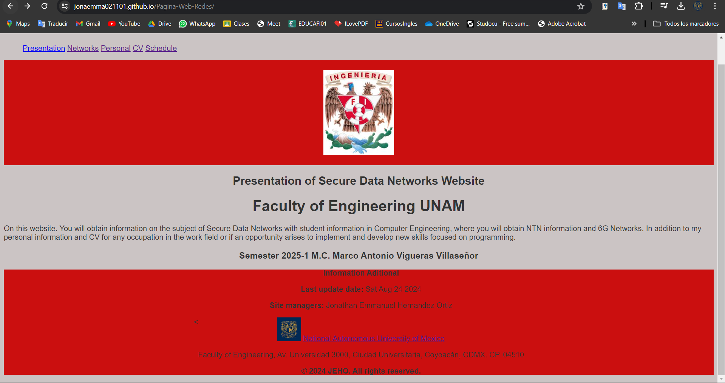

In the first tab, I summarize what I am going to do and what it is about or what is available on the website.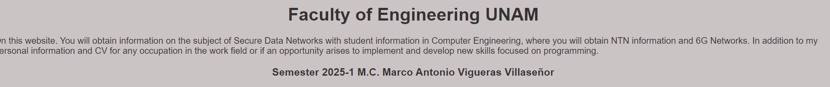 Academic information and everything related to the subject of Networks and the professor who teaches the course.



Information from the last day they entered the website and my name as the person who created the Website.

Link to the official UNAM website, address and copyright.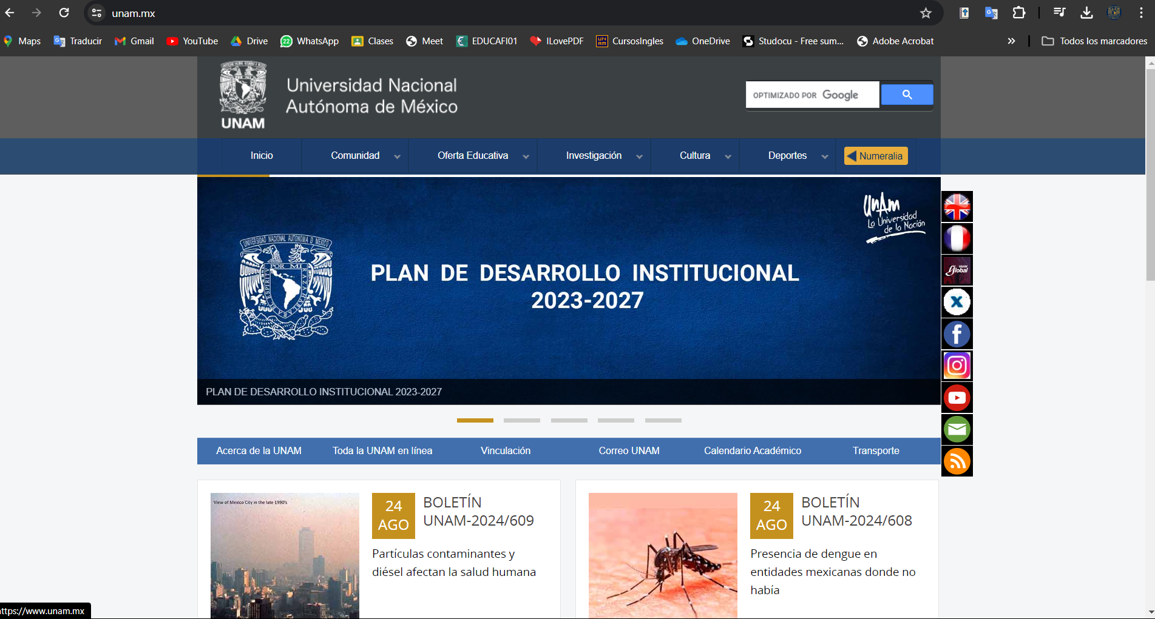

Clicking on the link will take us to this page.

Code:

<!DOCTYPE html>

<html lang="en">

<head>

    <meta charset="UTF-8">

    <meta name="viewport" content="width=device-width, initial-scale=1.0">

    <title>Perfil JEHO</title>

    <link rel="stylesheet" href="styles.css">

    <script src="script.js"></script>

    <link href="https://fonts.googleapis.com/css2?family=Kanit:wght@300&display=swap" rel="stylesheet">

    <style>

        .logotype {

            width: 150px;

            /* Ajusta el ancho del logotipo */

            height: auto;

            /* Mantiene la proporción del logotipo */

            display: block;

            /* Lo hace un elemento de bloque */

            margin: 20px auto;

            /* Centra el logotipo horizontalmente */

        }

        body {

            background-color: #cbc4c4;

            /* Color de fondo gris claro */

            color: #333;

            /* Color del texto para mejor contraste */

            font-family: Arial, sans-serif;

            /* Fuente de texto */

        }

        .fond-mitad {

            background-color: rgb(203, 15, 15);

            /* Color de fondo rojo */

            height: 30vh;

            /* Altura del 50% de la altura de la ventana del navegador */

            width: 100%;

            /* Ancho del 100% de la ventana del navegador */

            display: flex;

            /* Usamos flexbox para centrar el contenido */

            justify-content: center;

            /* Centra horizontalmente */

            align-items: center;

            /* Centra verticalmente */

        }

    </style>

    <link rel="icon" href="unam.jpeg" type="image/x-icon">

</head>

<body>

    <script src="https://cdn.jsdelivr.net/npm/bootstrap@5.3.2/dist/js/bootstrap.bundle.min.js" integrity="sha384-C6RzsynM9kWDrMNeT87bh95OGNyZPhcTNXj1NW7RuBCsyN/o0jlpcV8Qyq46cDfL" crossorigin="anonymous"></script>

    <h1 class="logo" onclick="location.href = 'index.html'">JEHO</h1>

    <nav>

        <ul>

            <a href="index.html">Presentation</a>

            <a href="redes.html">Networks</a>

            <a href="personal.html">Personal</a>

            <a href="cv.html">CV</a>

            <a href="horario.html">Schedule</a>

        </ul>

    </nav>

    <div class="fond-mitad"><img src="fi.jpeg" alt="Descriptión of Logotype" class="logotype"></div>

    <header>

        <center>

            <h2 class="title"> Presentation of Secure Data Networks Website</h2>

            <h1 class="school"> Faculty of Engineering UNAM</h1>

        </center>

        <p>

            On this website. You will obtain information on the subject of Secure Data Networks with student information in Computer Engineering, where you will obtain NTN information and 6G Networks. In addition to my personal information and CV for any occupation

            in the work field or if an opportunity arises to implement and develop new skills focused on programming.

            <center>

                <h3> Semester 2025-1 M.C. Marco Antonio Vigueras Villaseñor</h3>

            </center>

        </p>

    </header>

    <div class="fond-mitad">

        <<footer>

            <center>

                <section id="informacion-adicional">

                    <p><b>Information Aditional</b></p>

                    <p><b>Last update date:</b> <span id="ultima-actualizacion"></span></p>

                    <p><b>Site managers:</b> <span id="responsable-sitio"></span></p>

                    <div>

                        <img src="unam.jpeg" alt="UNAM" width="50">

                        <a href="https://www.unam.mx/">National Autonomous University of Mexico</a>

                        <p>Faculty of Engineering, Av. Universidad 3000, Ciudad Universitaria, Coyoacán, CDMX. CP. 04510</p>

                    </div>

                </section>

                <p class="small-footer"><b>&copy; 2024 JEHO. All rights reserved.</b></p>

                </footer>

            </center>

    </div>

    <script>

        // Obtiene la fecha actual y la establece como la fecha de última actualización

        var fechaActual = new Date();

        var elementoFecha = document.getElementById("ultima-actualizacion");

        elementoFecha.textContent = fechaActual.toDateString();

        // Establece el nombre del responsable del sitio

        var responsableSitio = "Jonathan Emmanuel Hernandez Ortiz";

        var elementoResponsable = document.getElementById("responsable-sitio");

        elementoResponsable.textContent = responsableSitio;

    </script>

</body>

</html>

**Tab 2**

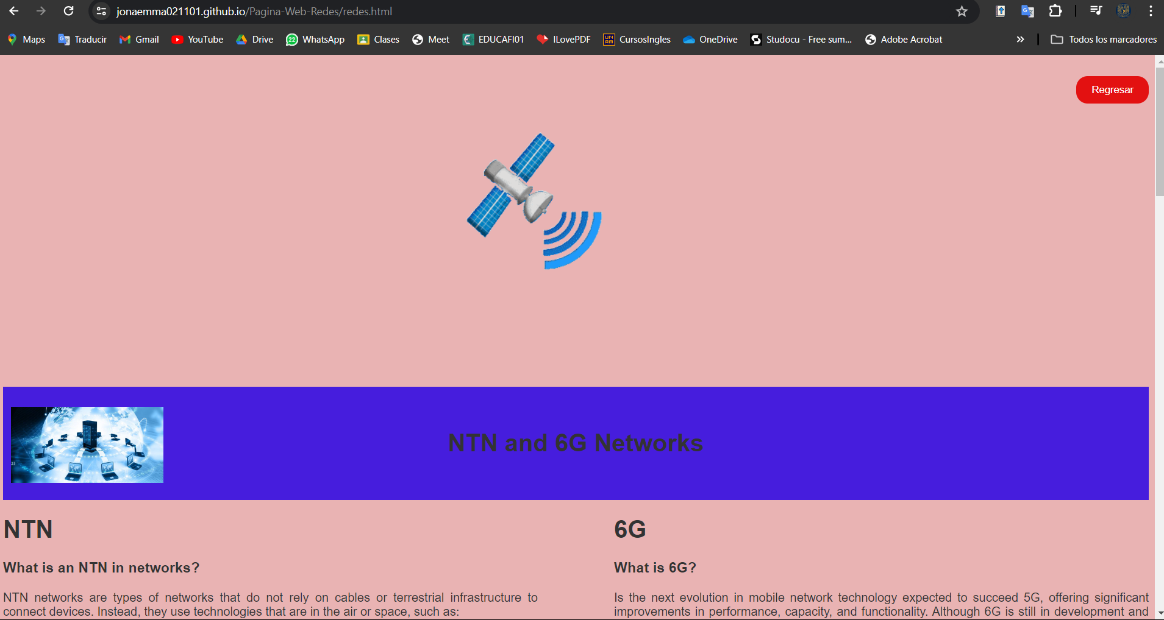

In this section we will find information about NTN networks and 6G Networks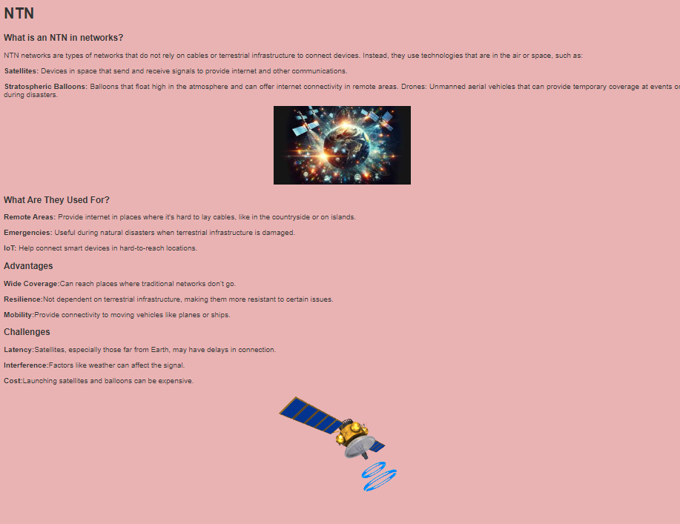

On the left side I explain what they consist of, what they are about and the advantages of using them.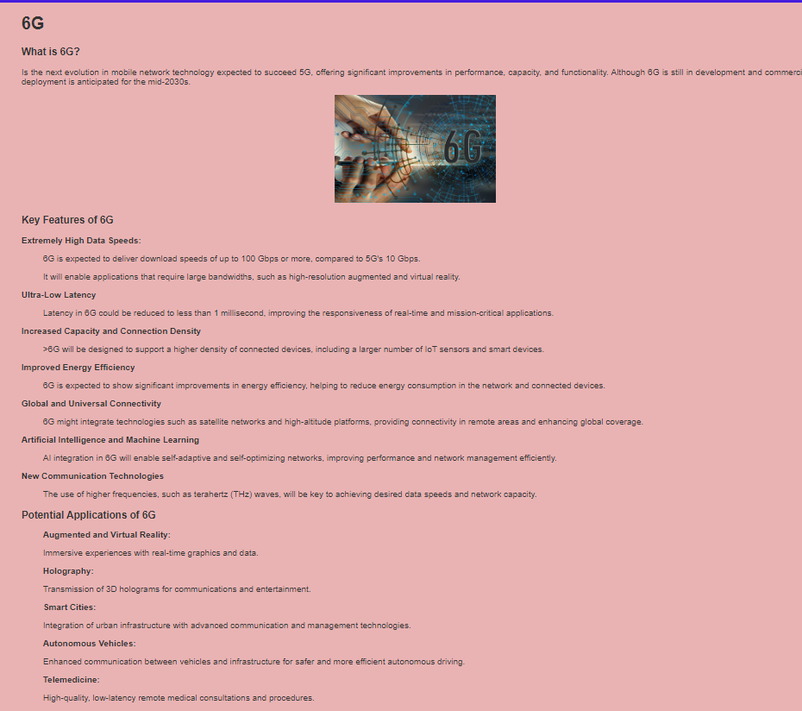

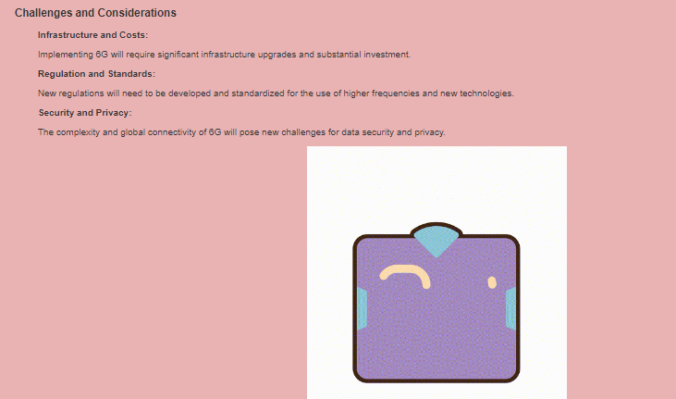

On the right side, he explained the great importance that 6G networks will have and what they consist of, as well as their advantages that they will bring to future technology.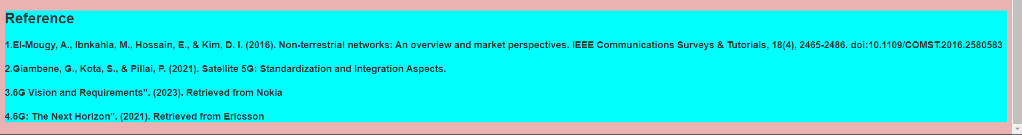

My bibliographical references are where the information I show above comes from.

Code:

<!DOCTYPE html>

<html lang="en">

<head>

    <meta charset="UTF-8">

    <meta name="viewport" content="width=device-width, initial-scale=1.0">

    <title>NTN and 6G Networks</title>

    <link href="https://fonts.googleapis.com/css2?family=Kanit:wght@300&display=swap" rel="stylesheet">

    <style>

        body {

            background-color: #e9b3b3;

            /* Color de fondo gris claro */

            color: #333;

            /* Color del texto para mejor contraste */

            font-family: Arial, sans-serif;

            /* Fuente de texto */

        }

        .text {

            background-color: rgb(70, 29, 221);

            /* Color de fondo rojo */

            height: 20vh;

            /* Altura del 50% de la altura de la ventana del navegador */

            width: 100%;

            /* Ancho del 100% de la ventana del navegador */

            display: flex;

            /* Usamos flexbox para centrar el contenido */

            justify-content: center;

            /* Centra horizontalmente */

            align-items: center;

            /* Centra verticalmente */

        }

        .imagen-relativa {

            position: relative;

            top: 130px;

            /* Desplaza la imagen hacia abajo */

            left: 10px;

            /* Desplaza la imagen hacia la derecha */

            width: 200px;

            height: auto;

        }

        #back-button {

            float: right;

            margin-top: 20px;

            padding: 10px 20px;

            background-color: #e31111;

            color: #fff;

            border: none;

            border-radius: 15px;

            cursor: pointer;

        }

        .contenedor-columnas {

            display: flex;

            /* Activa el modelo de flexbox */

            gap: 100px;

            /* Espacio entre las columnas */

        }

        .columna {

            flex: 1;

            /* Cada columna ocupa el mismo ancho */

        }

        .fond-reference {

            background-color: aqua;

            justify-content: center;

            width: 100%;

            /* Centra horizontalmente */

            /*align-items: center;*/

        }

    </style>

    <link rel="icon" href="redes.jpg" type="image/x-icon">

</head>

<body>

    <div>

        <button id="back-button" onclick="goBack()">Regresar</button>

        <center><img src="sateliteinicio.gif" alt="NTN"></center>

        <script>

            function goBack() {

                window.history.back();

            }

        </script>

    </div>

    <img src="redes.jpg" alt="Network" class="imagen-relativa">

    <div class="text">

        <h1> NTN and 6G Networks</h1>

    </div>

    <div class="contenedor-columnas">

        <div class="columna" style="text-align: justify">

            <h1>NTN</h1>

            <h3><b>What is an NTN in networks?</b></h3>

            <p>NTN networks are types of networks that do not rely on cables or terrestrial infrastructure to connect devices. Instead, they use technologies that are in the air or space, such as:</p>

            <p> <b>Satellites:</b> Devices in space that send and receive signals to provide internet and other communications.</p>

            <p><b>Stratospheric Balloons:</b> Balloons that float high in the atmosphere and can offer internet connectivity in remote areas. Drones: Unmanned aerial vehicles that can provide temporary coverage at events or during disasters.</p>

            <center><img src="ntn.jpeg" alt="NTN"></center>

            <h3><b>What Are They Used For?</b></h3>

            <p><b>Remote Areas:</b> Provide internet in places where it's hard to lay cables, like in the countryside or on islands.</p>

            <p><b>Emergencies:</b> Useful during natural disasters when terrestrial infrastructure is damaged.</p>

            <p><b>IoT:</b> Help connect smart devices in hard-to-reach locations.</p>

            <h3><b>Advantages</b></h3>

            <p><b>Wide Coverage:</b>Can reach places where traditional networks don’t go.</p>

            <p><b>Resilience:</b>Not dependent on terrestrial infrastructure, making them more resistant to certain issues.</p>

            <p><b>Mobility:</b>Provide connectivity to moving vehicles like planes or ships.</p>

            <h3>Challenges</h3>

            <p><b>Latency:</b>Satellites, especially those far from Earth, may have delays in connection.</p>

            <p><b>Interference:</b>Factors like weather can affect the signal.</p>

            <p><b>Cost:</b>Launching satellites and balloons can be expensive.</p>

            <center><img src="satelite.gif" alt="NTN"></center>

        </div>

        <div class="columna" style="text-align: justify">

            <h1>6G</h1>

            <h3>What is 6G?</h3>

            <p> Is the next evolution in mobile network technology expected to succeed 5G, offering significant improvements in performance, capacity, and functionality. Although 6G is still in development and commercial deployment is anticipated for the

                mid-2030s.

            </p>

            <center><img src="red6g.jpg" alt="NTN" width="300"> </center>

            <h3>Key Features of 6G</h3>

            <b>Extremely High Data Speeds:</b>

            <ol>

                <p>6G is expected to deliver download speeds of up to 100 Gbps or more, compared to 5G's 10 Gbps.</p>

                <p>It will enable applications that require large bandwidths, such as high-resolution augmented and virtual reality.</p>

            </ol>

            <b>Ultra-Low Latency</b>

            <ol>

                <p>Latency in 6G could be reduced to less than 1 millisecond, improving the responsiveness of real-time and mission-critical applications.</p>

            </ol>

            <b>Increased Capacity and Connection Density</b>

            <ol>

                <p>>6G will be designed to support a higher density of connected devices, including a larger number of IoT sensors and smart devices.</p>

            </ol>

            <b>Improved Energy Efficiency</b>

            <ol>

                <p>6G is expected to show significant improvements in energy efficiency, helping to reduce energy consumption in the network and connected devices.</p>

            </ol>

            <b>Global and Universal Connectivity</b>

            <ol>

                <p>6G might integrate technologies such as satellite networks and high-altitude platforms, providing connectivity in remote areas and enhancing global coverage.</p>

            </ol>

            <b>Artificial Intelligence and Machine Learning</b>

            <ol>

                <p>AI integration in 6G will enable self-adaptive and self-optimizing networks, improving performance and network management efficiently.</p>

            </ol>

            <b>New Communication Technologies</b>

            <ol>

                <p>The use of higher frequencies, such as terahertz (THz) waves, will be key to achieving desired data speeds and network capacity.</p>

            </ol>

            <h3>Potential Applications of 6G</h3>

            <ol>

                <b>Augmented and Virtual Reality:</b>

                <p>Immersive experiences with real-time graphics and data.</p>

            </ol>

            <ol>

                <b>Holography:</b>

                <p>Transmission of 3D holograms for communications and entertainment.</p>

            </ol>

            <ol>

                <b>Smart Cities:</b>

                <p>Integration of urban infrastructure with advanced communication and management technologies.

                </p>

            </ol>

            <ol>

                <b>Autonomous Vehicles:</b>

                <p>Enhanced communication between vehicles and infrastructure for safer and more efficient autonomous driving.</p>

            </ol>

            <ol>

                <b>Telemedicine: </b>

                <p>High-quality, low-latency remote medical consultations and procedures.</p>

            </ol>

            <h3>Challenges and Considerations</h3>

            <ol>

                <b>Infrastructure and Costs:</b>

                <p>Implementing 6G will require significant infrastructure upgrades and substantial investment.</p>

            </ol>

            <ol>

                <b>Regulation and Standards:</b>

                <p>New regulations will need to be developed and standardized for the use of higher frequencies and new technologies.</p>

            </ol>

            <ol>

                <b>Security and Privacy:</b>

                <p>The complexity and global connectivity of 6G will pose new challenges for data security and privacy.</p>

            </ol>

            <center><img src="red6g.gif" alt="6G"> </center>

        </div>

    </div>

    <div class="fond-reference">

        <h2>Reference</h2>

        <h4>1.El-Mougy, A., Ibnkahla, M., Hossain, E., & Kim, D. I. (2016). Non-terrestrial networks: An overview and market perspectives. IEEE Communications Surveys & Tutorials, 18(4), 2465-2486. doi:10.1109/COMST.2016.2580583</h4>

        <h4>2.Giambene, G., Kota, S., & Pillai, P. (2021). Satellite 5G: Standardization and Integration Aspects.</h4>

        <h4>3.6G Vision and Requirements". (2023). Retrieved from Nokia</h4>

        <h4>4.6G: The Next Horizon". (2021). Retrieved from Ericsson</h4>

        <h4></h4>

        <h4></h4>

    </div>

</body>

</html>

**Tab 3**

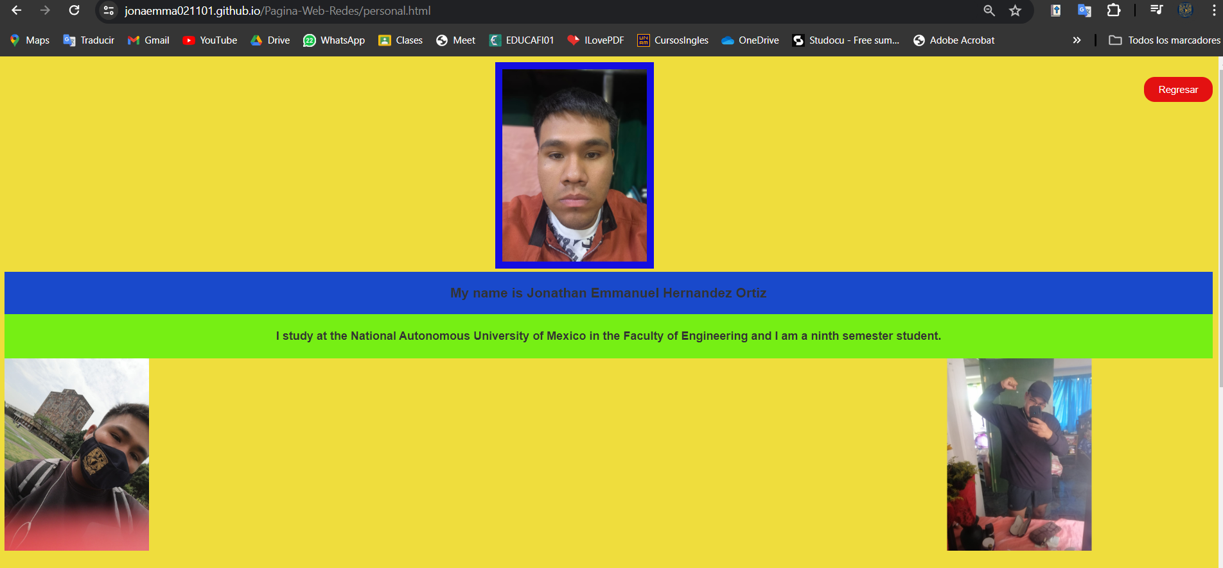

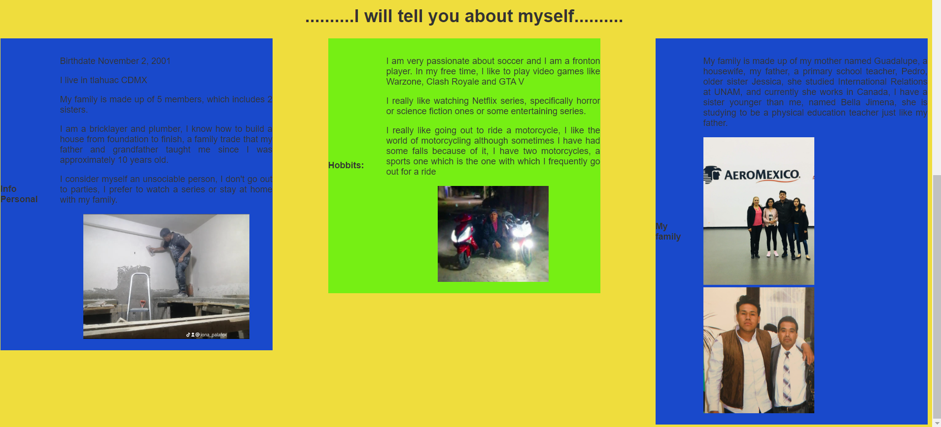

In this section, I talk about myself, important information, favorite hobbies and I talk a little about my family.

Code:

<!DOCTYPE html>

<html lang="en">

<head>

    <meta charset="UTF-8">

    <meta name="viewport" content="width=device-width, initial-scale=1.0">

    <title>PERSONAL INFORMATION</title>

    <link rel="icon" href="mia.jpeg" type="image/x-icon">

    <style>

        body {

            background-color: #efdd3d;

            /* Color de fondo gris claro */

            color: #333;

            /* Color del texto para mejor contraste */

            font-family: Arial, sans-serif;

            /* Fuente de texto */

            align-items: center;

        }

        .imagen-con-marco {

            border: 10px solid rgb(21, 14, 224);

            /* Grosor de 5px, estilo sólido y color negro */

        }

        .text {

            background-color: rgb(25, 73, 203);

            width: 100%;

            display: flex;

            /* Usamos flexbox para centrar el contenido */

            justify-content: center;

            /* Centra horizontalmente */

            align-items: center;

            /* Centra verticalmente */

        }

        .text2 {

            background-color: rgb(118, 239, 20);

            width: 100%;

            display: flex;

            /* Usamos flexbox para centrar el contenido */

            justify-content: center;

            /* Centra horizontalmente */

            align-items: center;

            /* Centra verticalmente */

        }

        .contenedor-columnas {

            display: flex;

            /* Activa el modelo de flexbox */

            gap: 100px;

            /* Espacio entre las columnas */

        }

        .columna {

            flex: 1;

            /* Cada columna ocupa el mismo ancho */

        }

        .img_der {

            transform: translate(1100px, 00px);

        }

        #back-button {

            float: right;

            margin-top: 20px;

            padding: 10px 20px;

            background-color: #e31111;

            color: #fff;

            border: none;

            border-radius: 15px;

            cursor: pointer;

        }

    </style>

</head>

<body>

    <button id="back-button" onclick="goBack()">Regresar</button>

    <script>

        function goBack() {

            window.history.back();

        }

    </script>

    <div>

        <center><img src="mia.jpeg" width="200" class="imagen-con-marco"></center>

    </div>

    <div class="text">

        <h3>My name is Jonathan Emmanuel Hernandez Ortiz</h3>

    </div>

    <div class="text2">

        <h4>I study at the National Autonomous University of Mexico in the Faculty of Engineering and I am a ninth semester student.</h4>

    </div>

    <div>

        <img src="miacu.jpeg" alt="CU" width="200">

        <img src="miacasa.jpeg" alt="CU" width="200" class="img_der">

    </div>

    <center>

        <h1>..........I will tell you about myself..........</h1>

    </center>

    <div class="contenedor-columnas">

        <div class="columna" style="text-align: justify">

            <div class="text">

                <b>Info Personal</b>

                <ol>

                    <p>Birthdate November 2, 2001</p>

                    <p>I live in tlahuac CDMX</p>

                    <p>My family is made up of 5 members, which includes 2 sisters.</p>

                    <p>I am a bricklayer and plumber, I know how to build a house from foundation to finish, a family trade that my father and grandfather taught me since I was approximately 10 years old.</p>

                    <p>I consider myself an unsociable person, I don't go out to parties, I prefer to watch a series or stay at home with my family.</p>

                    <center><img src="albañil.jpeg" width="300"></center>

                </ol>

            </div>

        </div>

        <div class="columna" style="text-align: justify">

            <div class="text2">

                <b>Hobbits:</b>

                <ol>

                    <p>I am very passionate about soccer and I am a fronton player. In my free time, I like to play video games like Warzone, Clash Royale and GTA V</p>

                    <p>I really like watching Netflix series, specifically horror or science fiction ones or some entertaining series.</p>

                    <p>I really like going out to ride a motorcycle, I like the world of motorcycling although sometimes I have had some falls because of it, I have two motorcycles, a sports one which is the one with which I frequently go out for a ride</p>

                    <center><img src="motos.jpeg" alt="Motos" width="200"></center>

                </ol>

            </div>

        </div>

        <div class="columna" style="text-align: justify">

            <div class="text">

                <b>My family</b>

                <ol>

                    <p>My family is made up of my mother named Guadalupe, a housewife, my father, a primary school teacher, Pedro, older sister Jessica, she studied International Relations at UNAM, and currently she works in Canada, I have a sister younger

                        than me, named Bella Jimena, she is studying to be a physical education teacher just like my father.</p>

                    <img src="familia.jpeg" alt="Familia" width="200">

                    <img src="padre.jpeg" alt="Familia" width="200"> </ol>

            </div>

        </div>

    </div>

</body>

</html>

**Tab 4**

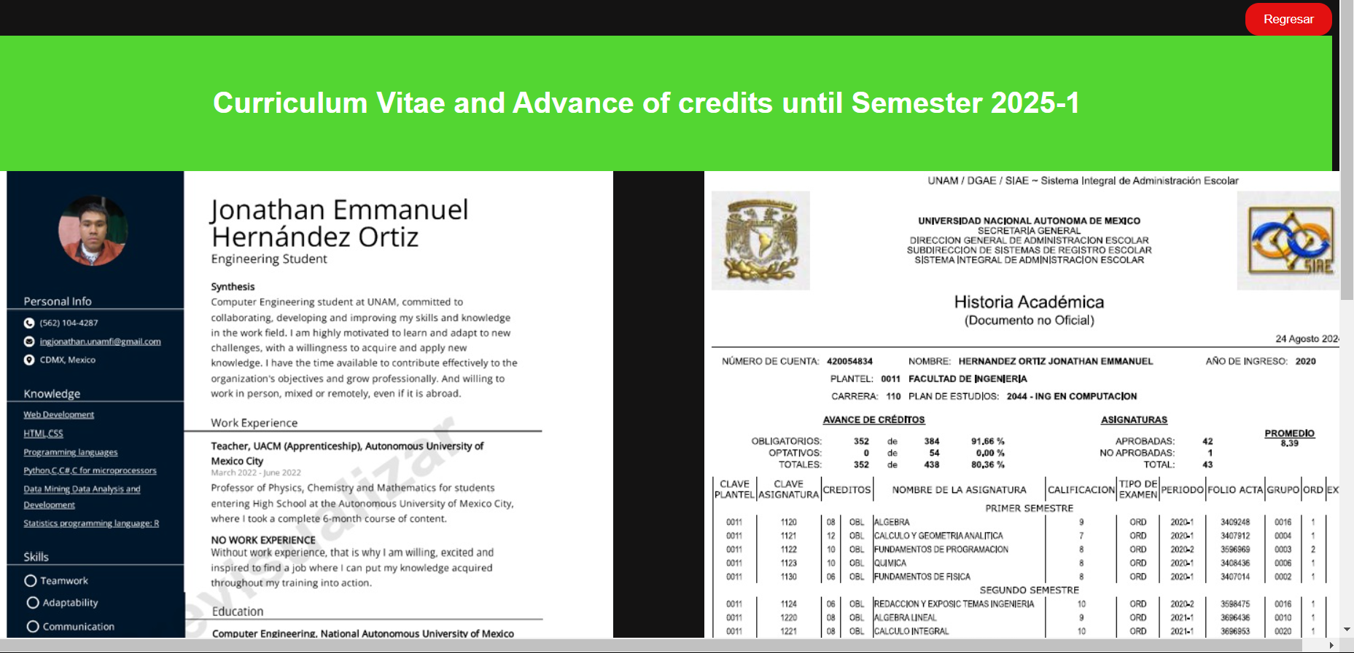

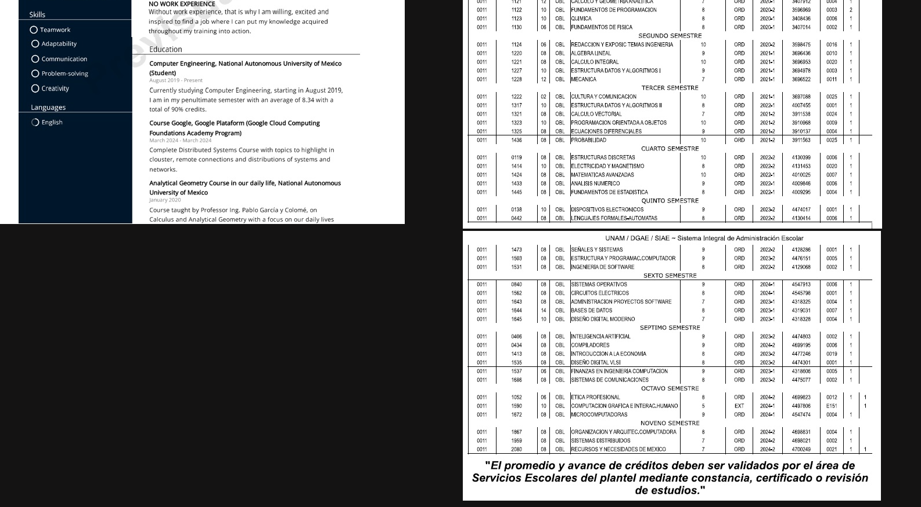

This section is the most important, because here is my CV and academic history, it talks about what I have done academically and my history of subjects with an average until this semester 2025-1.

Code:

<!DOCTYPE html>

<html lang="en">

<head>

    <meta charset="UTF-8">

    <meta name="viewport" content="width=device-width, initial-scale=1.0">

    <title>Curriculum Vitae</title>

    <style>

        body {

            background-color: #141313;

            /* Color de fondo gris claro */

            color: #ffffff;

            /* Color del texto para mejor contraste */

            font-family: Arial, sans-serif;

            /* Fuente de texto */

        }

        #back-button {

            float: right;

            margin-top: 20px;

            padding: 10px 20px;

            background-color: #e31111;

            color: #fff;

            border: none;

            border-radius: 15px;

            cursor: pointer;

        }

        .fond-mitad {

            background-color: rgb(83, 214, 50);

            /* Color de fondo rojo */

            height: 20vh;

            /* Altura del 50% de la altura de la ventana del navegador */

            width: 100%;

            /* Ancho del 100% de la ventana del navegador */

            display: flex;

            /* Usamos flexbox para centrar el contenido */

            justify-content: center;

            /* Centra horizontalmente */

            align-items: center;

            /* Centra verticalmente */

        }

        .contenedor-columnas {

            display: flex;

            /* Activa el modelo de flexbox */

            gap: 100px;

            /* Espacio entre las columnas */

        }

        .columna {

            flex: 1;

            /* Cada columna ocupa el mismo ancho */

        }

    </style>

</head>

<body>

    <button id="back-button" onclick="goBack()">Regresar</button>

    <script>

        function goBack() {

            window.history.back();

        }

    </script>

    <div class="fond-mitad">

        <h1>Curriculum Vitae and Advance of credits until Semester 2025-1</h1>

    </div>

    <div class="contenedor-columnas">

        <div class="=columna" style="text-align: justify">

            <img src="cv.jpeg" alt="CV">

        </div>

        <div class="=columna" style="text-align: justify">

            <img src="historial1.jpeg" alt="CV">

            <img src="historial2.jpeg" alt="CV">

        </div>

    </div>

</body>

</html>

**Tab 5**

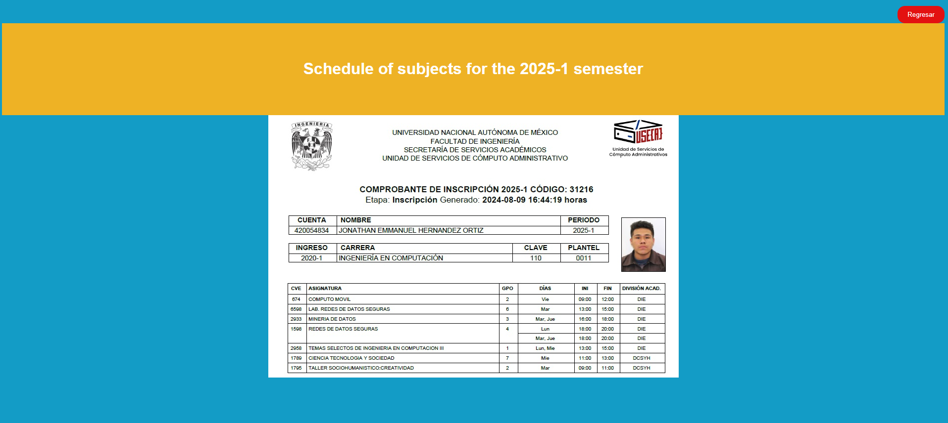

Finally, my course record or proof of studies, about the subjects I have taken this semester.

Code:

<!DOCTYPE html>

<html lang="en">

<head>

    <meta charset="UTF-8">

    <meta name="viewport" content="width=device-width, initial-scale=1.0">

    <title>Document</title>

    <style>

        body {

            background-color: #139cc6;

            /* Color de fondo gris claro */

            color: #ffffff;

            /* Color del texto para mejor contraste */

            font-family: Arial, sans-serif;

            /* Fuente de texto */

        }

        #back-button {

            float: right;

            margin-top: 20px;

            padding: 10px 20px;

            background-color: #e31111;

            color: #fff;

            border: none;

            border-radius: 15px;

            cursor: pointer;

        }

        .fond-mitad {

            background-color: rgb(238, 178, 37);

            /* Color de fondo rojo */

            height: 20vh;

            /* Altura del 50% de la altura de la ventana del navegador */

            width: 100%;

            /* Ancho del 100% de la ventana del navegador */

            display: flex;

            /* Usamos flexbox para centrar el contenido */

            justify-content: center;

            /* Centra horizontalmente */

            align-items: center;

            /* Centra verticalmente */

        }

        #back-button {

            float: right;

            margin-top: 20px;

            padding: 10px 20px;

            background-color: #e31111;

            color: #fff;

            border: none;

            border-radius: 15px;

            cursor: pointer;

        }

    </style>

</head>

<body>

    <button id="back-button" onclick="goBack()">Regresar</button>

    <script>

        function goBack() {

            window.history.back();

        }

    </script>

    <div class="fond-mitad">

        <center>

            <h1>Schedule of subjects for the 2025-1 semester </h1>

        </center>

    </div>

</body>

<center><img src="estudios.jpeg" alt="Tira_Materias"></center>

</html>

Observation



All tabs have a button to return to the main tab.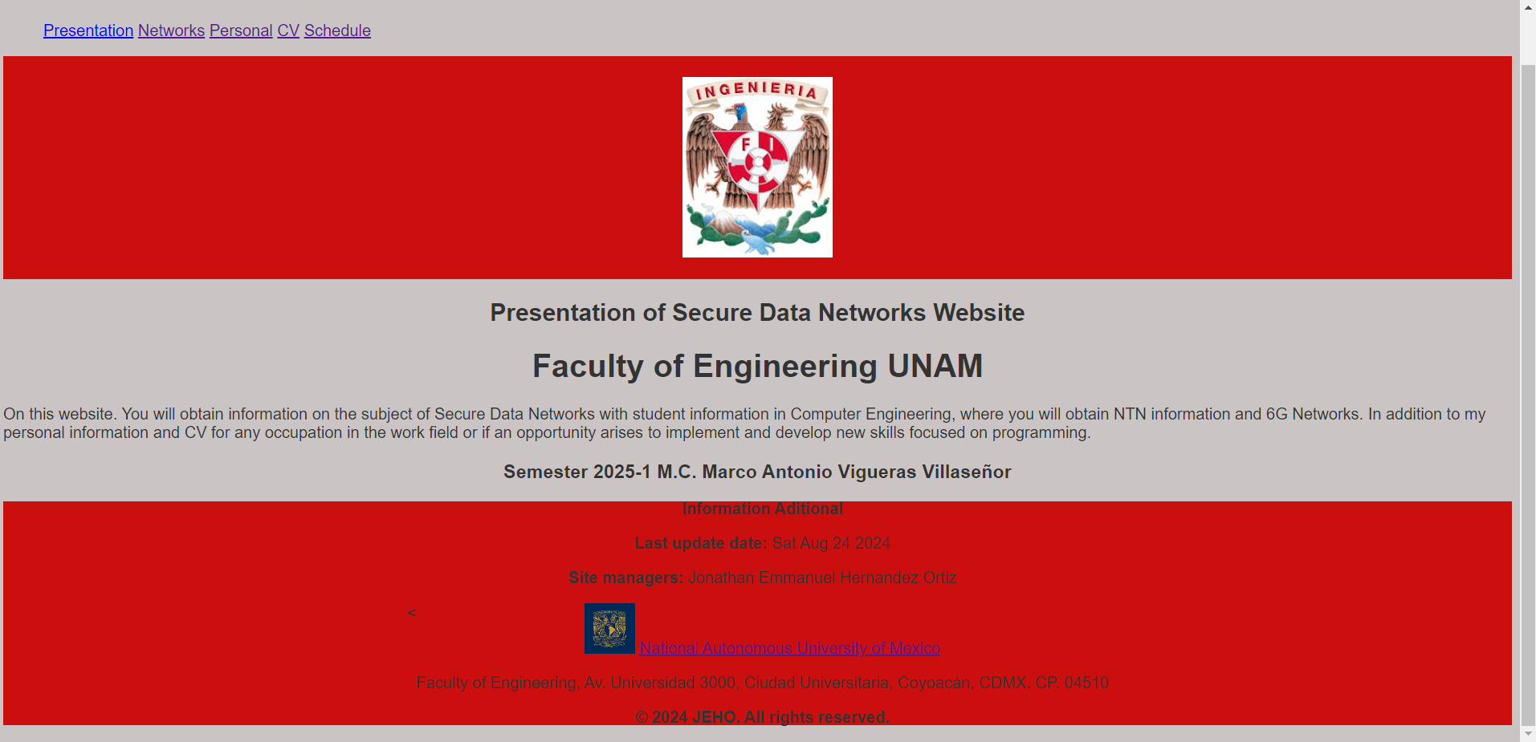

Code:

#back-button {

            float: right;

            margin-top: 20px;

            padding: 10px 20px;

            background-color: #e31111;

            color: #fff;

            border: none;

            border-radius: 15px;

            cursor: pointer;

        }

<button id="back-button" onclick="goBack()">Regresar</button>

    <script>

        function goBack() {

            window.history.back();

        }

    </script>

LINK:

<https://jonaemma021101.github.io/Pagina-Web-Redes/>

Repository of Git Hub.